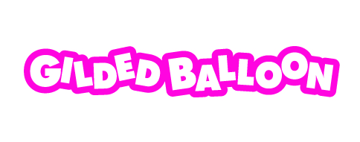
Accessibility Guide
Edinburgh Festival Fringe 2022

- INTRODUCTION

Welcome to Gilded Balloon’s Fringe Accessibility Guide. Gilded Balloon is committed to a policy of equal opportunities for all and we want everyone to have the best time at the Fringe.
We operate 3 venues housing 18 performance spaces and bars during the Edinburgh Festival Fringe.
This document should provide you with all necessary information with regards to access in and around our venues. If you need any further information please contact us using the details below.

- CONTACT DETAILS
Email: admin@gildedballoon.co.uk - a member of our team will get back to you within 3 days. Feedback is always welcome.

Phone: Gilded Balloon Box Office (0)131 622 6552.

In Person: During the festival (Wednesday 3 August- Sunday 28 August 2022) we operate a physical Box Office at each of our festival venues (details below). The Box Office at the National Museum of Scotland has a lowered desk and is normally quieter than our other box office. Location and opening times of the Museum below.
- GENERAL INFORMATION

Bookable Access Facilities: Gilded Balloon provides free tickets for companions. To book your companion ticket, call our Box Office on (0)131 622 6552.
Assistance Dogs: Gilded Balloon welcomes Assistance Dogs in all of our venues. Please ask a member of staff on arrival if you require any assistance.
Special Effects: Some of our shows include the use of strobe lighting and/or haze. This is listed on the individual show page on the Gilded Balloon website.
Customers with Medical Requirements: There are trained First Aiders in each of our venues. If you need to bring food, drink or medication with you, we are happy to accommodate this. Please contact a member of staff if you need assistance.
Edinburgh during the Fringe: The roads and streets of Edinburgh become extremely congested during the festival. We suggest that all patrons bear this in mind and leave extra time to travel to our venues.
Early Access: We endeavour to ensure that everyone is able to enjoy the Fringe in a comfortable and secure environment. If you require extra time or a specific seat in our performance spaces please speak to a member of staff on arrival to the venue so we can allow extra time and/or reserve seats if required. You can also contact us in advance if you prefer.
Euan’s Guide: To see reviews of our venues and to add your own reviews we recommend Euan’s Guide: www.euansguide.com We welcome your feedback and regularly check reviews on Euan’s Guide.
- GILDED BALLOON FRINGE VENUES

GILDED BALLOON TEVIOT
Teviot Row House, 13 Bristo Square, EH8 9AJ
Box Office: 0131 622 6552
Venue Opening Times: 10am – 5am daily

Seven of the nine performance venues at Gilded Balloon Teviot are accessible, the others have stairs. Please note that the lifts in Teviot Row House cannot at present accommodate motorised wheelchairs. The external platform lift and internal lift can only accommodate manual wheelchairs due to weight restrictions. We apologise for the inconvenience this causes.
Arrival Guide
The venue can be accessed via 2 entrances:
- Front Entrance (stepped-access)
Access to the front entrance is via 9 steps which do not incorporate handrails, contrasting nosings or a tactile surface at the top. The front entrance door is fastened open during standard opening hours (see opening hours above).
There is a disabled call point located on a railing before and to the left of the main entrance which can be used to gain assistance. The call point is within comfortable reach of wheelchair users.
- Garden Entrance (platform lift or steps)
Access to the garden entrance is via a gate which is located beyond the aforementioned disabled call point, before and to the left of the front entrance. The gate is fastened open during standard opening hours (see opening hours above). There is a platform lift to the first floor where the box office is located as well as stairs.
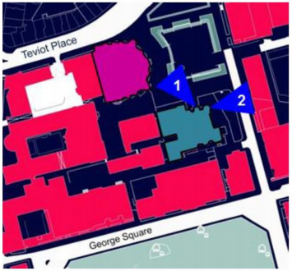
From the ground floor an internal lift is available to most floors. Please note that the lifts in Teviot Row House cannot at present accommodate motorised wheelchairs. The external platform lift and internal lift can only accommodate manual wheelchairs due to weight restrictions. We apologise for the inconvenience this causes. All venues are accessible by level access except the Billiard Room and Balcony which are accessed by 16 steps up.

Performance Spaces
DEBATING HALL
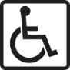
Wheelchair Access, Lift Access, 6 Wheelchair Spaces

DINING ROOM
Wheelchair Access, Lift Access, 2 Wheelchair Spaces

NIGHTCLUB
Wheelchair Access, Lift Access, 3 Wheelchair Spaces

WINE BAR
Wheelchair Access, Lift Access, 4 Wheelchair Spaces

SPORTSMANS
Wheelchair Access, Lift Access, 2 Wheelchair Spaces

WEE ROOM
Wheelchair Access, Lift Access, 2 Wheelchair Spaces

THE TURRET
Wheelchair Access, Lift Access, 2 Wheelchair Space

BALCONY
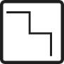
Accessed by 16 stairs up.
BILLIARD ROOM
Accessed by 16 stairs up.

Box Office
The Charles Street Box Office (outside Teviot) can be accessed from street level – please be aware that this box office does not have lowered access windows however staff are trained to assist all customers.
The Main Box office is located inside Teviot Row House on the ground floor, inside the front entrance and has a lower access desk.
Toilet Facilities
Accessible toilets are located by the lifts on the ground floor, level 1 and level 2.
The nearest Changing Places toilet facilities are available at the National Museum of Scotland. For more details click here: http://www.uktoiletmap.org/toilet/view/1149
Bar/Café Facilities
The New Amphion is located on the second floor via the lift and has a lowered access counter for ordering meals, snacks and drinks.
All other bars at Teviot are accessible including the Gilded Garden. None have lowered counters however staff are trained to assist all patrons.
Travel guide
Arriving by train: The nearest train station is Edinburgh Waverley and is approximately 15 minute walk or 8 minute taxi ride away.
Arriving by bus: The nearest bus stops are located on Lothian Street approximately 130 metres from Teviot Row House. Lothian bus service numbers 2, 41, 42, 47 & 67 stop on Lothian Street and numerous other services stop on South Bridge. Details of timetables are available from Lothian Buses https://lothianbuses.co.uk/
Cycling: There are bike racks in Bristo Square opposite Teviot Row House
Parking: The closest Blue Badge parking is along Howden Street, approximately 400m from the entrance to Teviot. Please note that all parking spaces around George Square are closed off to the public in August. Parking spaces highlighted in Sky Blue are for Blue Badge holders, parking spaces highlighted in Dark Blue are pay and display parking areas.

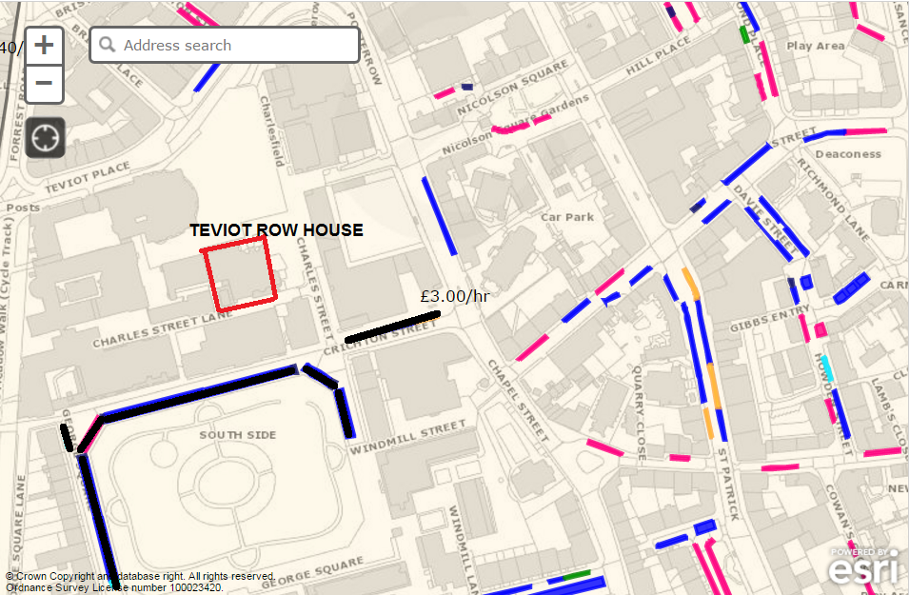
Sky Blue = Blue Badge Holder parking spaces
Dark Blue = Pay & Display parking spaces
(Pink = resident only parking bays)

Further information on parking can be found at the Edinburgh Council website here: http://www.edinburgh.gov.uk/info/20085/parking_spaces/507/parking_bay_locations
Drop-off: Taxis and cars are able to drop off at the junction of Crighton Street and Chapel Street (see map below). Please advise the Security Guard of your needs upon arrival. From this point there is level access to Teviot along Charles St.
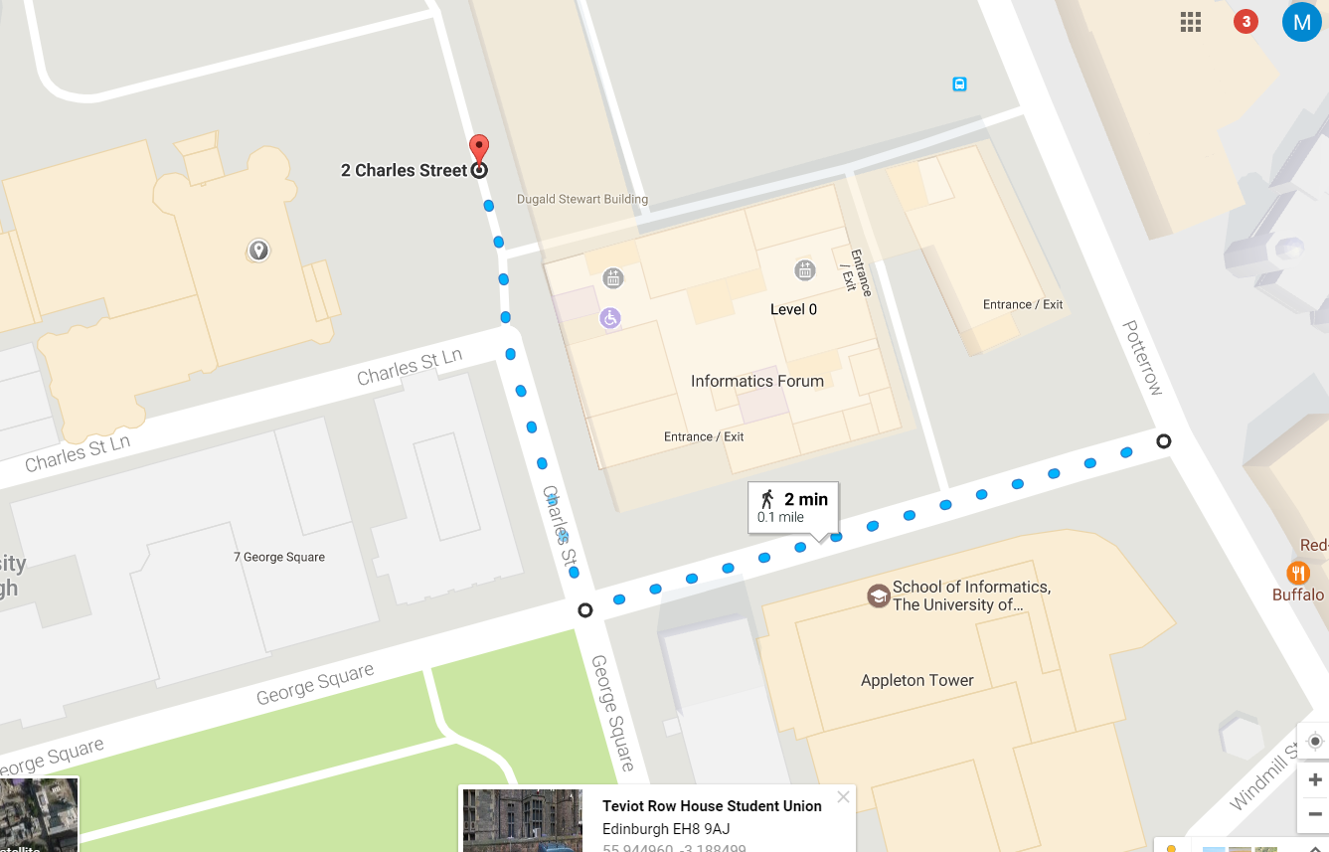
Gilded Balloon Teviot

Drop-off point

GILDED BALLOON AT THE MUSEUM
South Entrance, Lothian Street, EH1 1HB
Box Office 0131 622 6552
Venue Opening Times: 10am – midnight daily

Arrival Guide
There is level access to the Auditorium via the South Entrance on Lothian Street.
Performance Spaces
AUDITORIUM
Wheelchair Access, 2 Wheelchair Spaces
Box Office
The Museum Box Office is located inside the foyer of the Auditorium. This has a lowered access desk.
Food/Drink Facilities
There is a bar serving customers of Gilded Balloon at the Museum. The bar does not have lowered access but staff are trained to assist all customers.
Toilet Facilities
The museum has fully accessible toilet facilities in the foyer. In addition, the Museum has a Changing Places Toilet facility available during Museum opening hours. Further information here: https://changingplaces.uktoiletmap.org/toilet/view/1149
Travel Guide
Arriving by train: The nearest train station is Edinburgh Waverley and is approximately 15 minute walk or 8 minute car ride away.
Arriving by bus: The nearest bus stops are located on Lothian Street approximately 130 metres from the National Museum of Scotland. Lothian bus service numbers 2, 41, 42, 47 & 67 stop on Lothian Street and numerous other services stop on South Bridge. Details of timetables are available from Lothian Buses https://lothianbuses.co.uk/
Parking: The closest Blue Badge parking is along Chambers Street, about 250m from the venue (see map below).
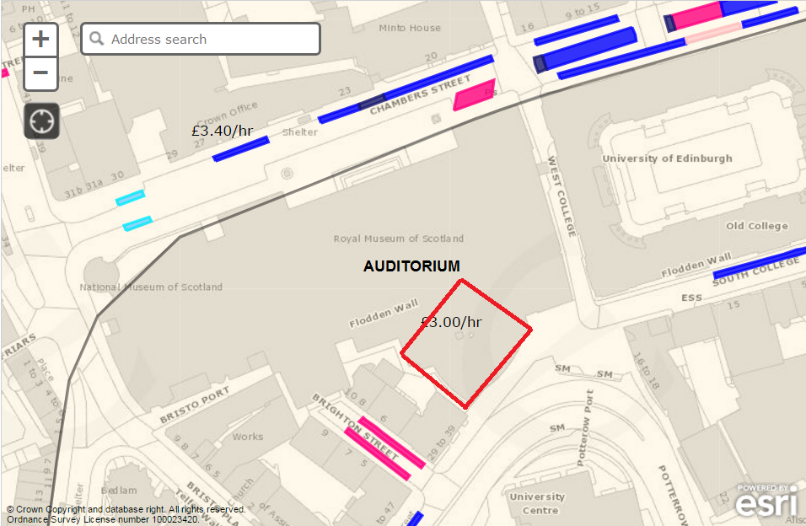
Sky Blue = Blue Badge Holder parking spaces
Dark Blue = Pay & Display parking spaces
Red box shows venue location
Further information on parking can be found at the City of Edinburgh Council website here: http://www.edinburgh.gov.uk/info/20085/parking_spaces/507/parking_bay_locations
Drop off: We recommend being dropped off at the loading bay on the corner of South & West College Street. It is then approximately a 1 minute walk to the venue entrance from there.
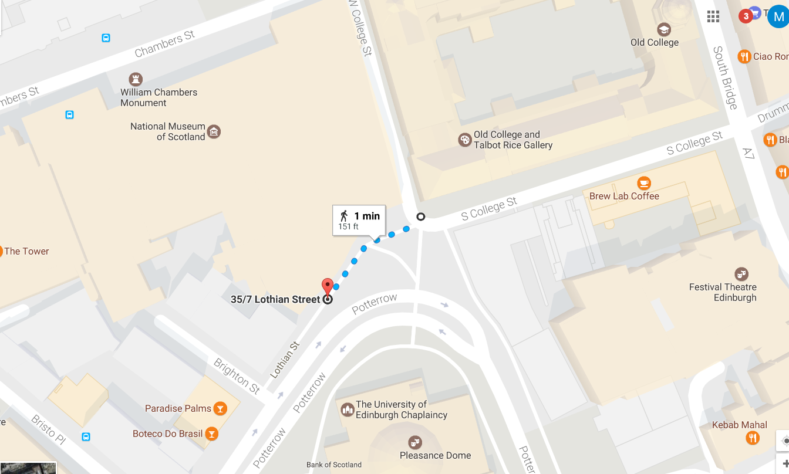

Gilded Balloon at the Museum
Drop-off point

GILDED BALLOON PATTER HOOSE
3 Chambers Street, EH1 1HT | Box Office: 0131 622 6552
Venue Opening Times: 10am – 5am daily

Gilded Balloon Patter Hoose is fully accessible with level access from the street and an internal lift and stairs which take users to all levels. Please note the width of the internal lift doors is 77cm (30 in) wide so may not be suitable for all wheelchairs.

Arrival Guide
The venue can be accessed via 2 entrances:
- Stepped entrance (stepped-access)
Access to the front entrance is via three steps with handrails, but no contrasting nosings or a tactile surface at the top. The main entrance door is fastened open during standard opening hours (see opening hours above).
- Accessible entrance (level access)
Level access is via a door which is located approx. 3 metres away from the stepped entrance. The door is closed during operating hours with staff members available to give access as required.

Performance Spaces
A lift is available to all floors. All venues are accessible via the building’s lift with level access once at the floor. Please note that the width of the lift to all floors is 77cm (30in) wide so may not be suitable for all wheelchairs.
DOONSTAIRS
Wheelchair Access, Lift Access, 2 Wheelchair Spaces

DRAM
Wheelchair Access, Lift Access, 2 Wheelchair Spaces

NIP
Wheelchair Access, Lift Access, 2 Wheelchair Spaces

THE OTHER YIN
Wheelchair Access, Lift Access, 2 Wheelchair Spaces

THE BIG YIN
Wheelchair Access, Lift Access, 2 Wheelchair Spaces

SNUG
Wheelchair Access, Level Access, 2 Wheelchair Spaces

COORIE
Wheelchair Access, Level Access, 2 Wheelchair Spaces

Box Office
The Patter Hoose Box Office is located in the main foyer at Adam House. This does not have a lowered desk but staff are trained to assist all customers.
Toilet Facilities
Accessible toilets are located on the Basement Level, Level one and level 3.
The nearest Changing Places toilet facilities are available at the National Museum of Scotland during opening hours. For more details click here: https://changingplaces.uktoiletmap.org/toilet/view/1149
Food & Drink
There is food and beverages available to customers at the entrance to the foyer. The bar and food vendors do not have lowered counters but staff are trained to assist all customers.

Travel guide
Arriving by train: The nearest train station is Edinburgh Waverley and is approximately 13 minute walk or 7 minute taxi ride away.
Arriving by bus: The nearest bus stops are located on South Bridge. Many Lothian bus services stop on South Bridge. Details of timetables are available from Lothian Buses https://lothianbuses.co.uk/
Parking: The closest Blue Badge parking is on Chambers Street approximately 150m from the entrance to Patter Hoose. Parking spaces highlighted in Sky Blue are for Blue Badge holders, parking spaces highlighted in Dark Blue are pay and display parking areas.

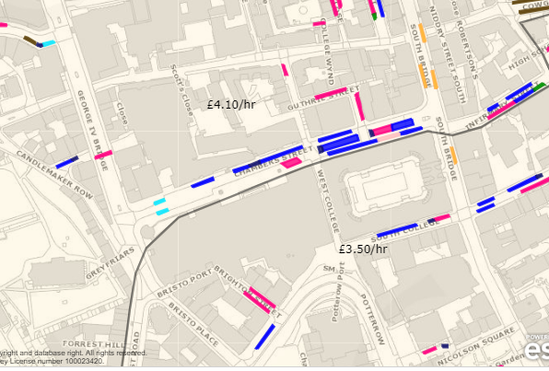

Sky Blue = Blue Badge Holder parking spaces
Dark Blue = Pay & Display parking spaces
Red box shows venue location

Further information on parking can be found at the City of Edinburgh Council website: http://www.edinburgh.gov.uk/info/20085/parking_spaces/507/parking_bay_locations
Drop Off: Taxis and cars are able to drop off outside Adam House if parking bays are available.

